**CS 207: Applied Database Practicum**

**In-Class Activity 5: Introduction to Stored Procedure, Stored Functions and Cursors, 23rd September, 2019**

In this activity, you will be working in Mysql.

Q1. Load the world.sql dump file uploaded in moodle (No need to load the dump file if it is already uploaded in your mysql server)

1. Create a stored procedure to display the country name, headofstate of the country and continent name for ASIA or EUROPE
2. Create a stored procedure that outputs the highest population (**value**) from the continents **EUROPE** and **AFRICA** and then use the value to find the name of that country.

**In this question load the database from the dump file (join.sql) given in moodle**

The Database has the following tables:

Customers: stores customer’s data.

Products: stores a list of scale model cars.

ProductLines: stores a list of product line categories.

Orders: stores sales orders placed by customers.

OrderDetails: stores sales order line items for each sales order.

Payments: stores payments made by customers based on their accounts.

Employees: stores all employee information as well as the organization structure such as who reports to whom.

Offices: stores sales office data.

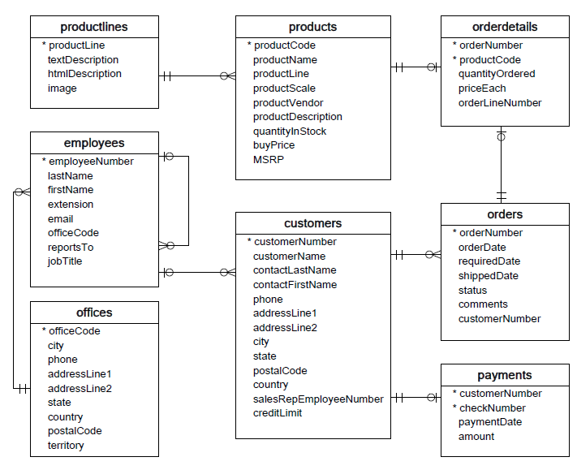

Q2. Create a stored function that takes as input the creditlimit of a customer from the **customers** table and assigns the following CustomerLevel to each customer:

i) if creditLimit > 50000 then assign CustomerLevel=**PLATINUM**

ii)if creditLimit <=50000 and creditLimit >=10000 then assign CustomerLevel=**GOLD**

iii) if creditLimit <=50000 then assign CustomerLevel=**SILVER**

**The output should be something similar to the image below**

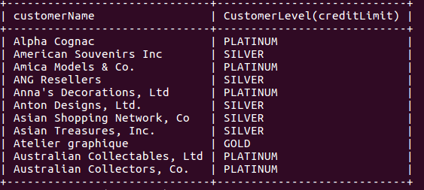

BONUS: ONLY if you have done the above steps, then you can try this bonus for an extra point.

Q3. Create a table temp with the following schema:

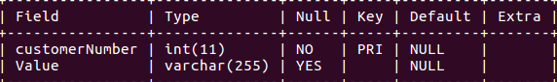

Create a stored procedure containing a cursor that

i) Fetches the customerNumber and creditLimit from **customers** table

ii) Fetches the customerNumber and Total amount paid by each customer from **payments** table

iii) If the Total amount > creditLimit then insert into the **temp** the customerNumber and “**limit exceeded**”

iv) If the Total amount < creditLimit then insert into the **temp** the customerNumber and “**below limit**”.

**The output should be something similar to the image below**

